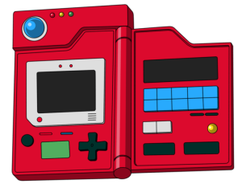

**ASI Pokedex Coding Exercise**

As a coding exercise we would like you to create a pokedex web app using the template provided to display a list of pokemon and allow the user to select a pokemon from the list and display information about it to the user.

Along with this technical specification document you should have been provided a template application called ngASI. In this template should be all the angular files needed to run ng-serve on your development console and run the application. The README.txt file should explain any libraries that need to be installed using NPM.

**Design Implementation**

For this exercise we would like to see the following:

Pokedex Dashboard:

* A table or data grid (Get as fancy as you want)
  + Should list the following columns
    - Id
    - Name
    - Type
  + A selection mechanism to choose the pokemon
  + Bonus Points: These columns can be filterable
  + Data can be found in app/data/pokemon.ts

Pokemon Details:

* Upon selection from the pokedex dashboard the pokemon details page should list the following pokemon details:
  + Pokemon Picture (These can be found in the /assets/img folder)
  + Id
  + Name
  + Type
  + Description
* Bonus Points: make this as fancy as you want, maybe show off some CSS and html capabilities but is not a requirement.